



**Linear Control Systems**

**(EE-379)**

**DE-44 Mechatronics Syndicate– C**

**Lab Report 3**

**Name of members:**

**NC** M. Ahmed Hussain Babar (**427781) PC** Abdul Haseeb Zahid (**432219)**

**NC** Muhammad Saqib (**411829)**

**Submitted to**: LE M.Shahzad Alam

**Abstract**

This lab explored first- and second-order linear control systems, with emphasis on their governing equations, time constants, damping ratios, and transient responses. Examples included RC circuits for first-order systems and RLC circuits and mass-spring-damper systems for second-order systems. Using Simulink and Simscape, an RLC circuit was modeled to simulate dynamic behavior. The model was linearized to obtain state-space representation and transfer function, enabling analysis of system performance metrics like rise time, peak time, overshoot, and settling time. The exercise reinforced ethical practices and group collaboration, providing a foundation for system modeling and linearization in control engineering.

**Introduction**

The objective of this laboratory exercise was to investigate first- and second-order systems in linear control theory using MATLAB Simulink. First-order systems are characterized by a single time constant τ, leading to exponential responses without oscillation, as seen in RC circuits or spring-damper setups (ignoring mass). Second-order systems involve second-degree differential equations, exhibiting behaviors dependent on damping ratio ζ, such as overdamped, critically damped, or underdamped responses, exemplified by RLC circuits and mass-spring-damper models. This lab built on prior time-domain concepts, introducing physical modeling in Simscape for accurate simulation of electrical and mechanical systems. Linearization tools were applied to derive mathematical representations, facilitating performance evaluation in applications like circuit design and vibration control.

**Objectives**

* To comprehend the characteristics of first-order systems, including time constant τ and exponential response.
* To understand second-order systems, focusing on damping ratio ζ, natural frequency, and performance metrics like rise time, peak time, overshoot, and settling time.
* To model physical systems (e.g., RLC circuits) in Simulink using Simscape blocks for simulation of transient responses.
* To perform model linearization in Simulink to obtain state-space and transfer function representations.

**Methodology**

1. Open Simulink and create a new model.
2. Add Step block from Simulink Library (Sources) to generate input signal (e.g., step from 0 to 1 at t=0).
3. Add Simulink-PS Converter (Simscape > Utilities) to convert Simulink signal to Physical Signal.
4. Add Controlled Voltage Source (Simscape > Electrical > Sources) connected to the converter output.
5. Build the series RLC circuit: Add Resistor (R), Inductor (L), Capacitor (C) from Simscape > Electrical > Passive, connected in series.
6. Connect the circuit to Ground (Simscape > Electrical > Reference).
7. Add Voltage Sensor (Simscape > Electrical > Sensors) across the capacitor to measure output voltage.
8. Add PS-Simulink Converter to convert physical signal back to Simulink signal.
9. Add Scope (Simulink > Sinks) to visualize the output.
10. Add Solver Configuration (Simscape > Utilities) to define simulation parameters.
11. Set component values (e.g., R=1 Ω, L=1 H, C=1 F for demonstration) and simulate the model.
12. Select the input (Step block output) and output (Voltage Sensor) points for linearization by right-clicking and choosing "Linearization Points."
13. Go to the Apps tab in the Simulink toolbar and select "Model Linearizer."
14. In the Model Linearizer, tick "Result Viewer" to enable visualization.
15. Click on "Step" input to perform linearization and plot the step response graph.
16. Export the linearized model to view state-space matrices and transfer function.

**Simulink Model**

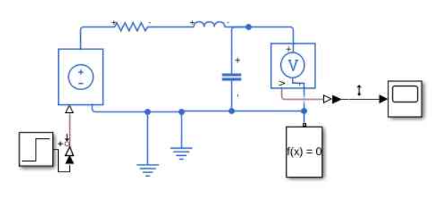

Figure 1: Simulink Model

**Results**

The MATLAB simulation produced the following output:

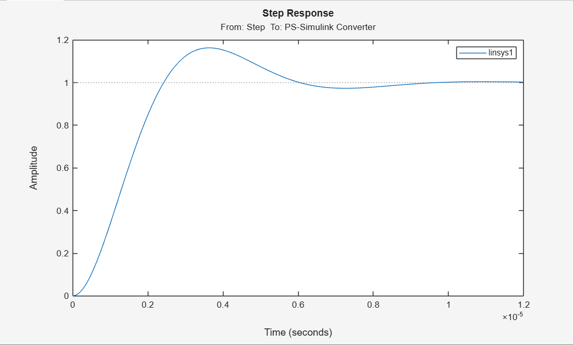

Figure 2: Output Graph

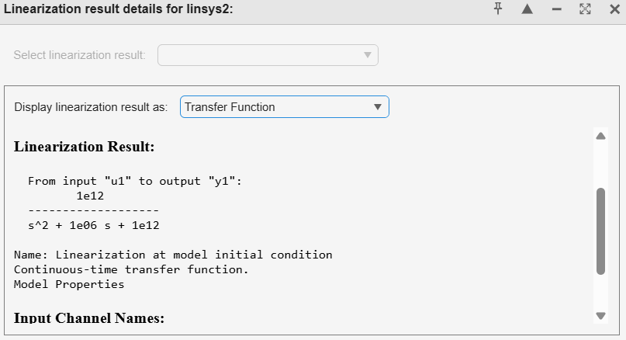

Figure 3: Linearization Results

**Discussion**

The lab bridged theoretical concepts of order systems with practical Simulink modeling. The RLC analogy to mass-spring-damper highlighted interdisciplinary applications. Linearization confirmed the expected mathematical forms, demonstrating how damping affects transients—e.g., low ζ increases overshoot but quickens response. Simscape's physical accuracy surpassed pure Simulink for real-world simulations. Challenges included selecting appropriate component values to observe distinct behaviors (e.g., underdamped vs. overdamped). Extensions could involve varying parameters to tune ζ or adding controllers. Limitations: Ideal components ignore nonlinearities like resistance variations. The exercise solidified skills for advanced control design.

**Conclusion**

This lab exercise enhanced understanding of first- and second-order systems through theory, modeling, and linearization. Simulink simulation and analysis tools provided insights into dynamic responses and performance metrics. Ethical collaboration fostered effective learning. The acquired knowledge prepares for complex system designs and controller implementations in mechatronics.